Community Support Program Report
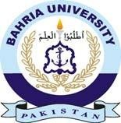



Name: Muhammad Taqui

Enrollment: 01-136221-021

Program: BSAI

Department: Computer Science

Email id:

01-136221-021@student.bahria.edu.pk

Contents

Activity Guidelines 3
STUDENT UNDERTAKING 4
Activity#1: Eidy Bag Donation 5
Date: Thursday, May 23, 2024. 5
Activity#2: Anti-Littering Drive, Madina Park 6
Date: Thursday, December 5, 2024. 6
Activity#3: School Teaching Activity 7
Day 1, Date: Wednesday, December 18, 2024. 7
Day 2, Date: Thursday, December 19, 2024. 8
Activity#4: Anti-Littering Drive, Madina Park 8
Date: Thursday, November 13, 2025. 8
Activity#5: Goodie Bag Distribution 9
Date: Wednesday, December 10, 2025. 9
Activity#6: Plantation Drive Activity 10
Date: Wednesday, December 17, 2025. 10
Conclusion: 11

Activity Guidelines

- The format of the report should be as described below.
- Copied reports will be cancelled right away and the student will have to face the consequences.
- Pictorial evidences of each activity are required. All the evidences along with the CSP report are to be mailed to CSP Coordinator.
- Individual reports are required and group reports will not be accepted. Each student must write his/her own experience of community support program in individual report. Reports must not be copied. Report must contain name, enrollment number, class, section and department.
- Please note that each student has to perform the activities assigned by the coordinator and all activities are mandatory. The number of hours will remain the same even if one activity is performed twice. i.e. Doing clothes donation twice will not result in 10 hrs (Except Iftar Drives). Therefore, all the activities must be performed in order to get 40 hrs. However, if anyone willingly wants to increase the quantity of items or length of activity, regardless of the hours, they are free to do so.


Bahria University
Community Support Program

STUDENT UNDERTAKING

1. I, Muhammad Taqui S/D/O Hafiz Zahoor Ahmad, Enrollment # 01-136221-021
, currently enrolled in Class BSAI-8A, have carefully read and
fully understood the policy requiring the completion of 40 hours of community service
as a mandatory degree requirement at Bahria University.

2. I hereby undertake the following:
• I have no objections to working on various community projects assigned
to me by the University.
• I will complete the required 40 hours of community service within the
assigned time frame.
• I pledge to abide by Bahria University’s rules and regulations regarding
discipline and conduct. I will not engage in any behavior that could harm
the reputation of the University, either on or off campus.
• I understand that failure to complete the community service hours may
jeopardize my degree and future at Bahria University.
• I acknowledge that I will be solely responsible for any copied or
plagiarized content in my reports, and I understand the consequences of
such actions.

3. I acknowledge and agree with the terms of the Community Service Program (CSP). I
understand that participation in the CSP is mandatory and essential for the completion
of my degree.

Muhammad Taqui

Signature Student

Activity#1: Eidy Bag Donation

Date: Thursday, May 23, 2024.

I have prepared 3 Eiddy bags for underprivileged children. These bags were distributed in different orphanages and shelter homes in Rawalpindi/Islamabad.

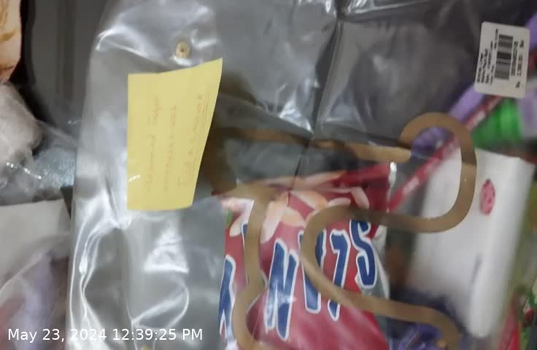
Bag # 01

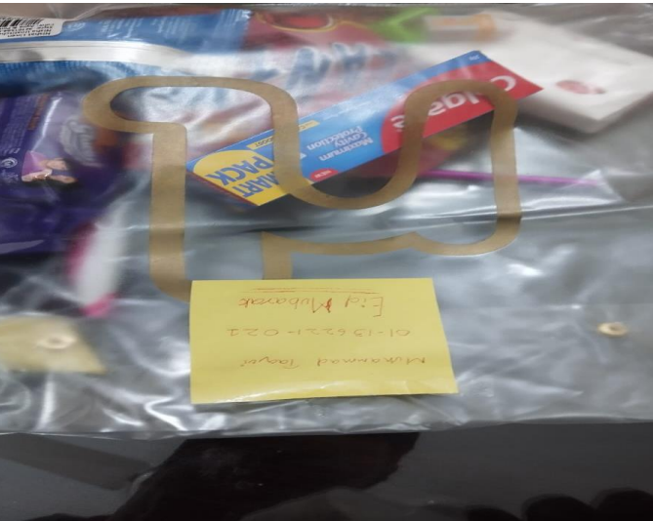

Bag # 02
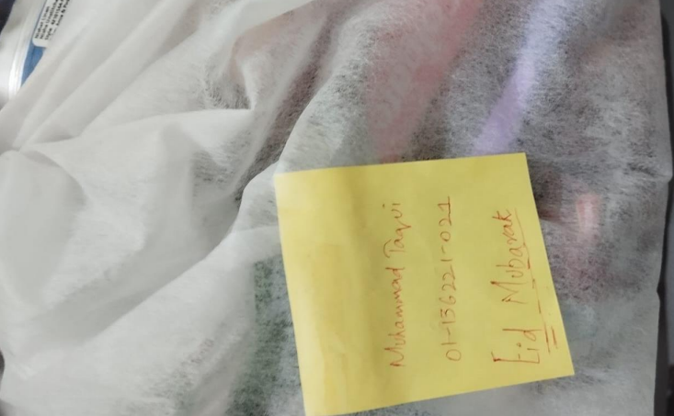

Bag # 03

Activity#2: Anti-Littering Drive, Madina Park
I participated in an Anti-Littering Drive at Madina Park where I collected litter and cleaned the public space alongside fellow volunteers.

Date: Thursday, December 5, 2024.

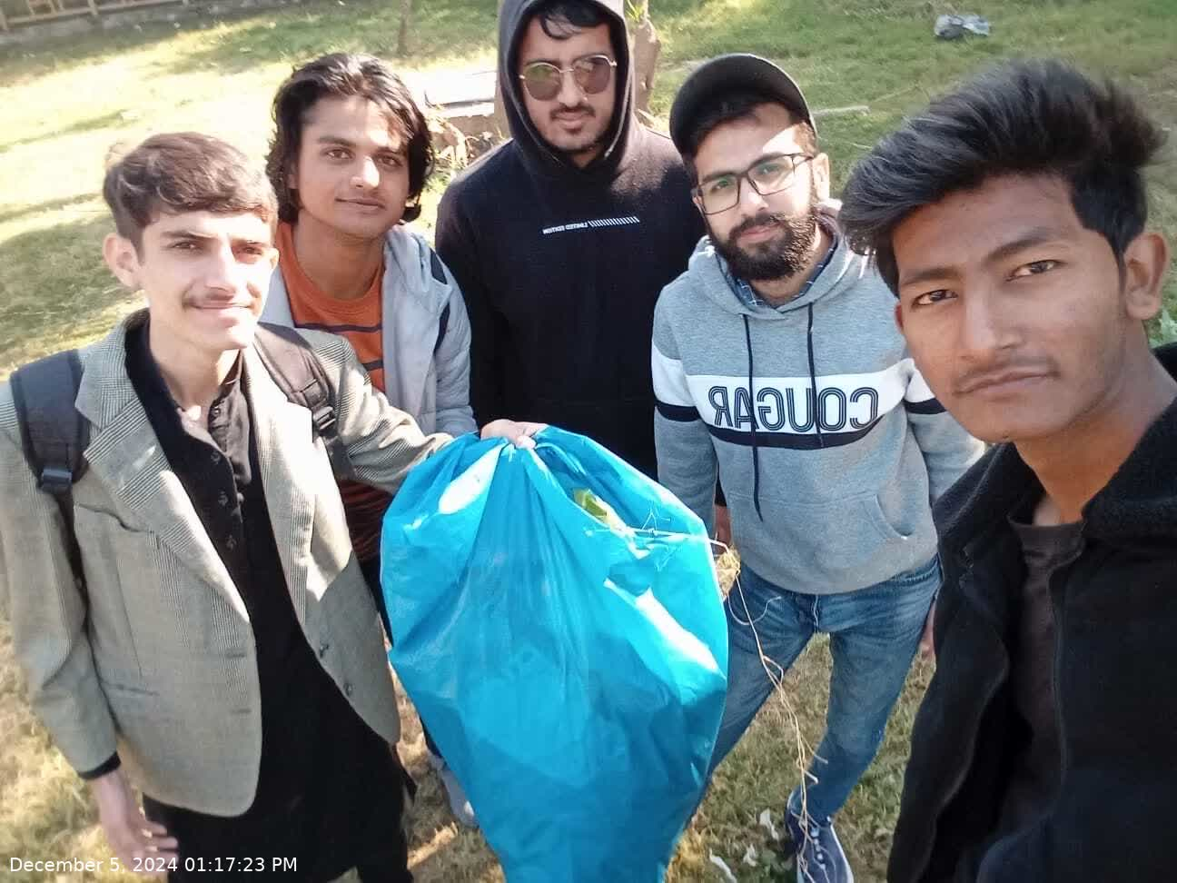

Activity#3: School Teaching Activity
I had the opportunity to teach Urdu and English to students of the Prep class at a local school.

Day 1, Date: Wednesday, December 18, 2024.

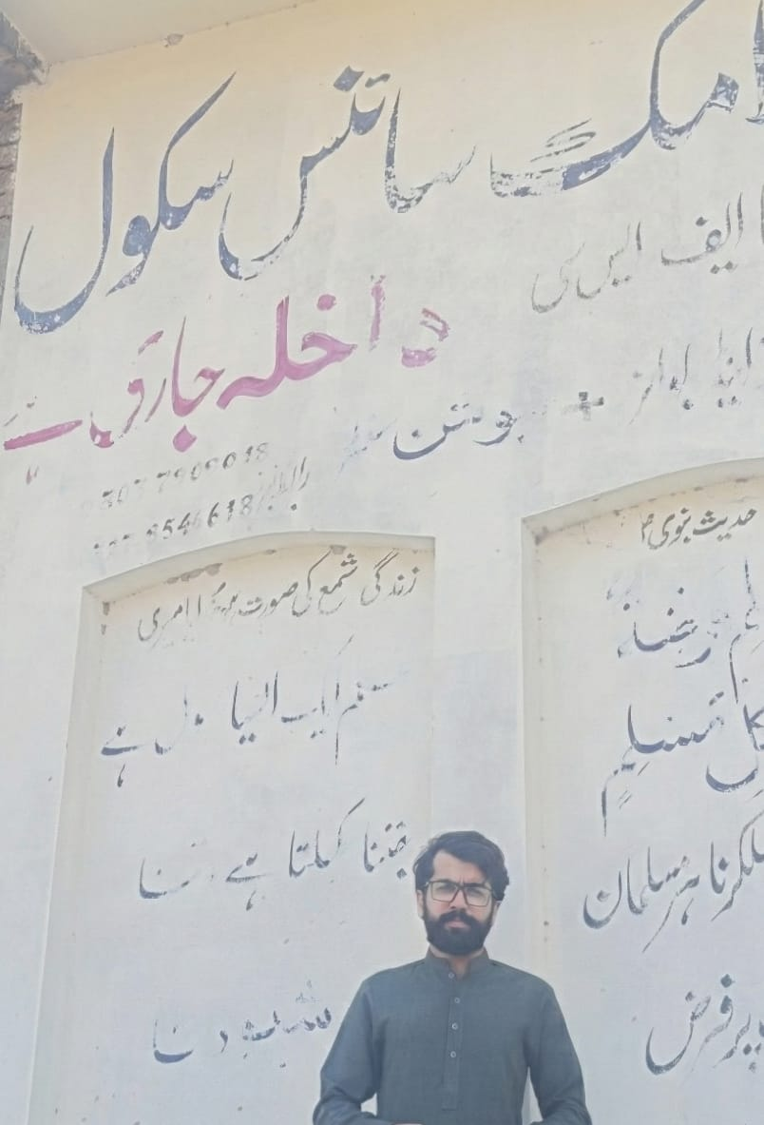

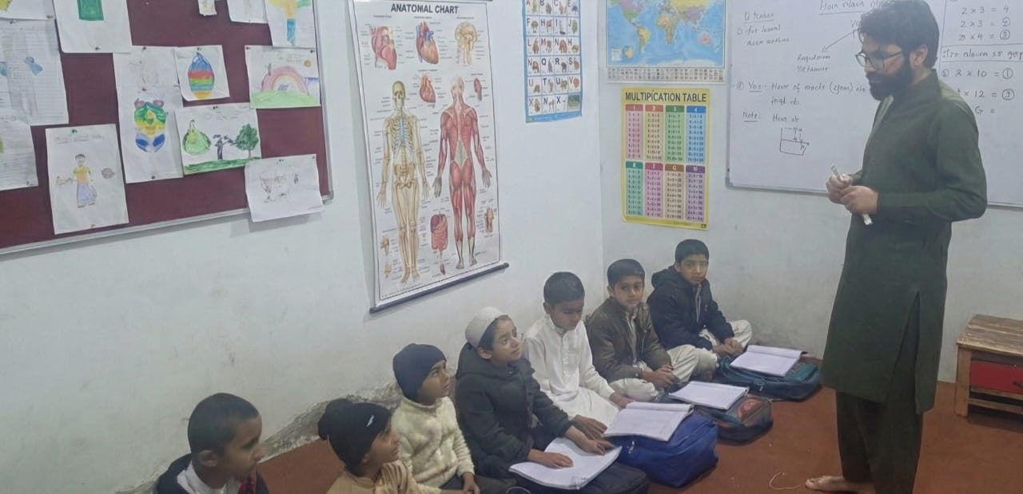

Day 2, Date: Thursday, December 19, 2024.

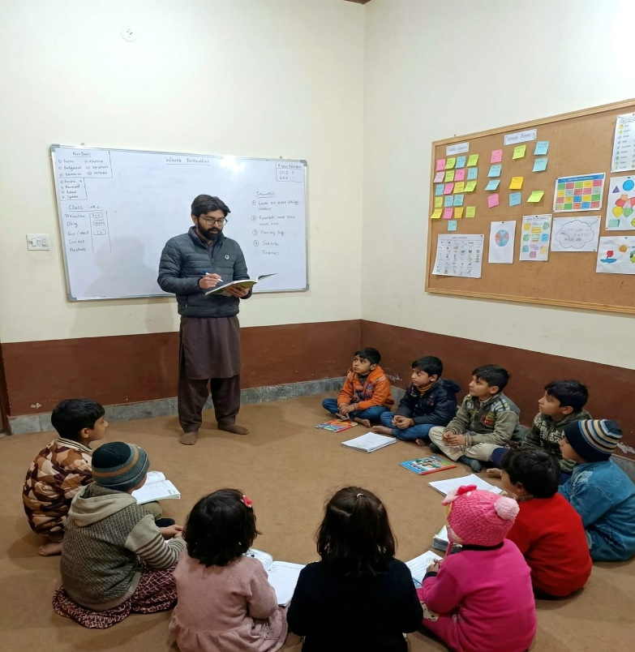

Activity#4: Anti-Littering Drive, Madina Park
I once again joined the Anti-Littering Drive at Madina Park to help keep the park clean and promote environmental awareness.

Date: Thursday, November 13, 2025.

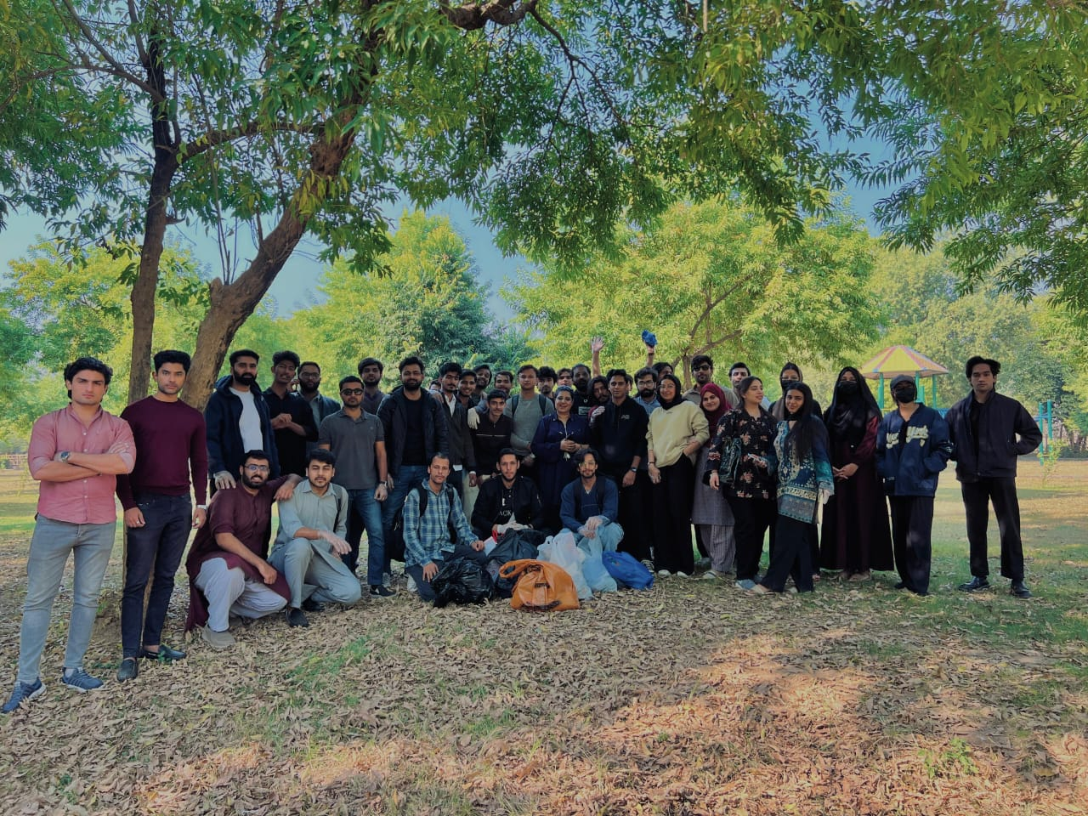

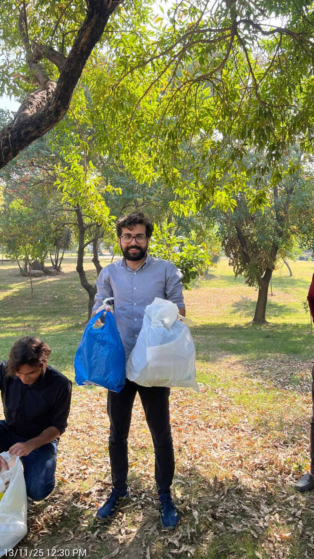

Activity#5: Goodie Bag Distribution
I prepared and distributed goodie bags to school kids.

Date: Wednesday, December 10, 2025.

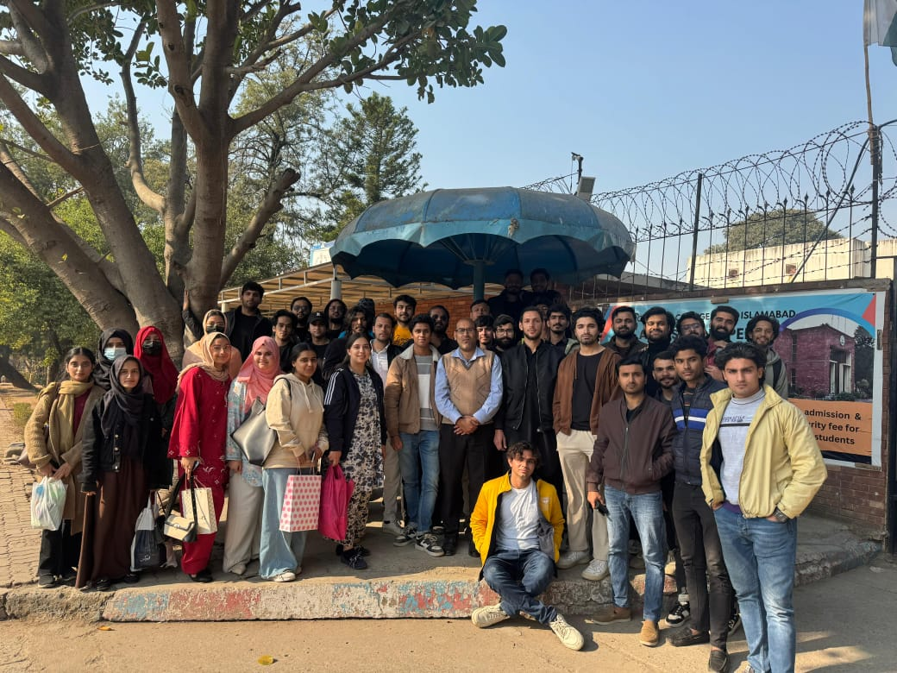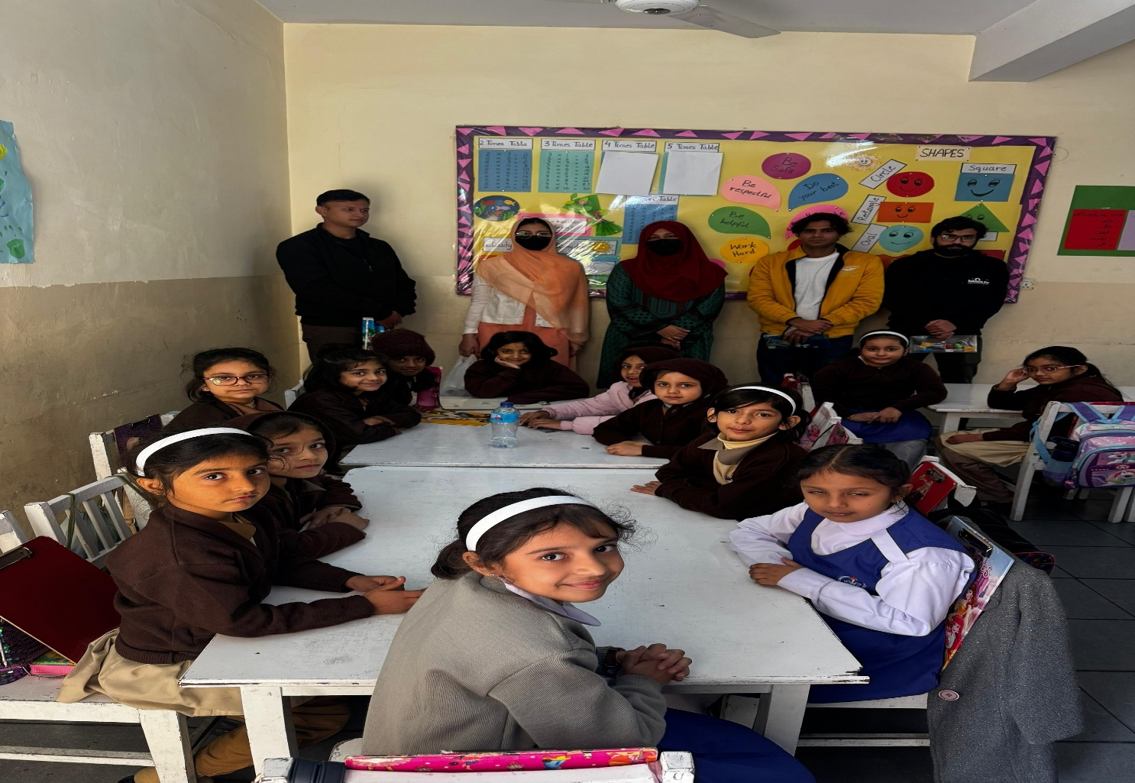

Activity#6: Plantation Drive Activity
I participated in a Plantation Drive where I planted trees to contribute towards environmental conservation and a greener future.

Date: Wednesday, December 17, 2025.

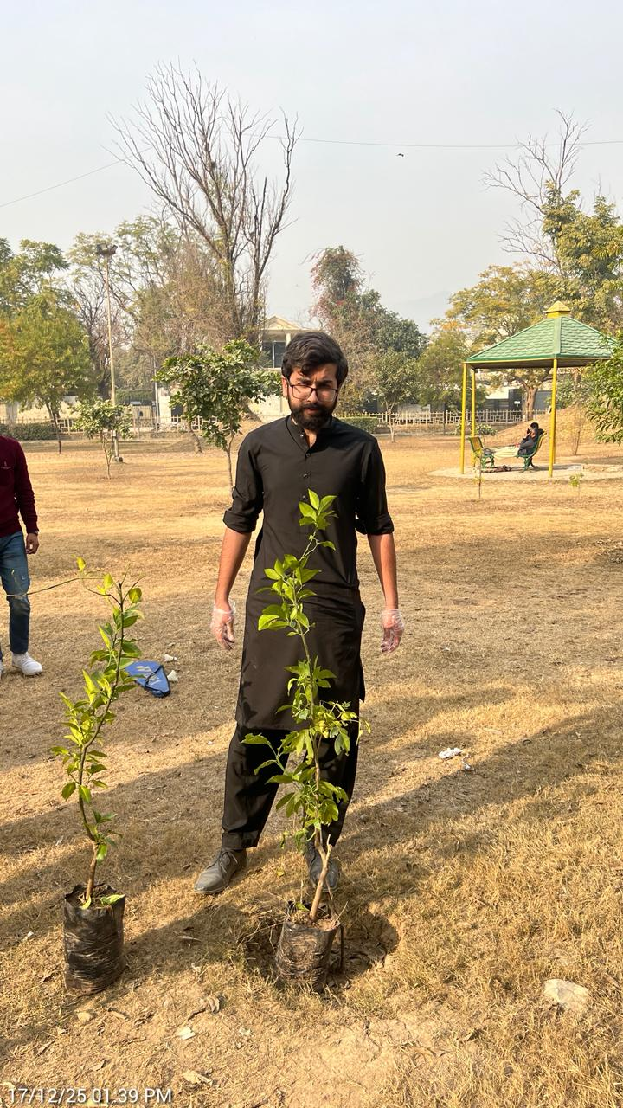

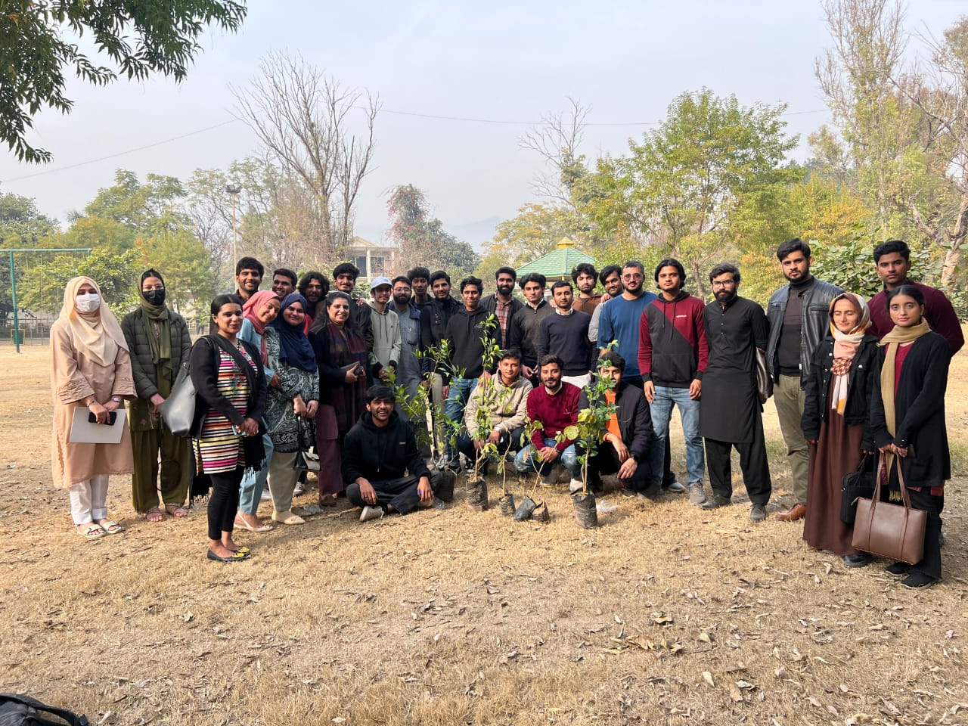

Conclusion:
Participating in the Community Support Program has been a truly enriching and humbling experience. Through activities like the Eidy Bag Donation, I witnessed how small acts of kindness can bring immense joy to underprivileged children. The Anti-Littering Drives at Madina Park taught me the importance of environmental responsibility and the power of collective action in creating cleaner spaces for our community.
The School Teaching Activity was particularly rewarding as I got to interact with young students and contribute to their learning. Seeing their enthusiasm reminded me of the impact that guidance and mentorship can have on shaping future generations. The Goodie Bag Distribution and Plantation Drive further reinforced that community service is about creating sustainable change and spreading hope.
These 40 hours have instilled in me a deeper sense of civic duty and empathy. I've learned that every individual can make a meaningful difference, no matter how small the contribution. This experience has shaped my character and strengthened my commitment to being an active member of society. I look forward to continuing community service beyond this academic requirement, as giving back to the community is both a responsibility and a privilege.

